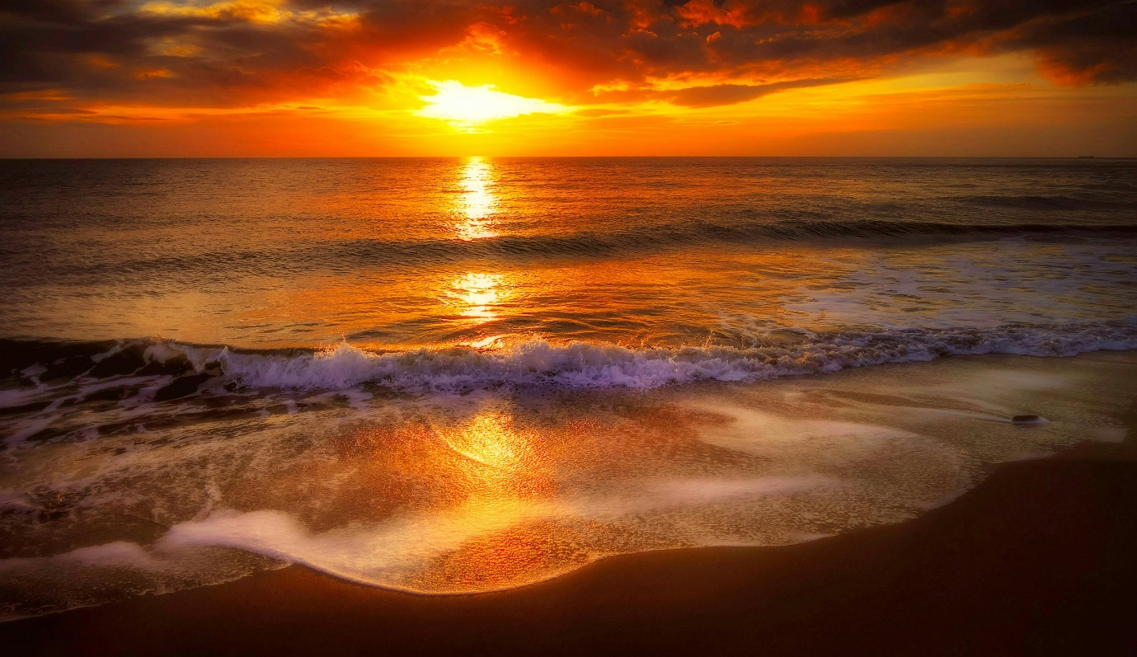

**Clifton beach**

**Clifton Beach, Karachi: The Jewel of Pakistan’s Coastline**

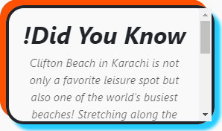Clifton Beach, also known as Sea View, is one of Karachi's most iconic destinations, offering a perfect blend of natural beauty, vibrant culture, and recreational activities. Situated along the Arabian Sea in the bustling metropolis of Karachi, this picturesque coastline is a favorite spot for both locals and tourists, providing a serene escape from the city's fast-paced life. Clifton Beach holds a special place in Karachi’s cultural and social landscape. Historically, it was one of the most frequented beaches during the British colonial era, where elite gatherings and social events were common. Over time, it has transformed into a public haven, welcoming people from all walks of life. Its sandy shores and open skies have served as a backdrop for countless memories, from family picnics to romantic walks at sunset.

**Evenings at Clifton Beach**

As the sun sets over the Arabian Sea, Clifton

Beach transforms into a lively and vibrant space.

The beach is illuminated by streetlights and the glow

of nearby attractions, creating a festive atmosphere.

Street performers, musicians, and local vendors add to the evening's charm, making it an excellent spot for socializing and enjoying Karachi’s nightlife by the sea.

**Natural Beauty and Scenic Views**

Stretching along the Arabian Sea, Clifton Beach offers stunning panoramic views of the ocean. The soft, golden sand, coupled with the rhythmic sound of waves crashing against the shore, creates an atmosphere of tranquility. On clear evenings, the beach becomes a magical place, with hues of orange and pink painting the sky as the sun sets.  
  
The cool sea breeze provides a refreshing contrast to Karachi’s otherwise warm climate, making Clifton Beach an ideal year-round destination. Whether you're enjoying a quiet stroll or simply sitting on the sand, the natural beauty of the beach offers a perfect escape for relaxation and reflection.  
  
Clifton Beach is more than just a place to enjoy nature; it’s a bustling hub for activities and entertainment. Families flock here to enjoy camel and horse rides along the shoreline, while adventure seekers can indulge in beach buggies or kite flying. Local vendors add to the charm by offering traditional snacks like spicy corn (bhutta) and cold drinks, enhancing the authentic Pakistani experience.  
  
For thrill-seekers, jet skiing and speedboat rides provide a dose of adrenaline, while those looking for a quieter experience can opt for fishing or simply dipping their feet in the cool waters. The beach is also a favorite spot for cricket and football enthusiasts, with friendly matches often played on its sandy expanse.

**Nearby Attractions**

Clifton Beach is surrounded by several attractions that further enhance its appeal. The famous Dolmen Mall and Boat Basin food street are just a short distance away, offering a variety of shopping and dining options. Visitors can also explore the beautiful Quaid-e-Azam House Museum or the serene Mohatta Palace, both located nearby. For those seeking a spiritual experience, the iconic shrine of Abdullah Shah Ghazi stands proudly overlooking the sea.

***RIDING***

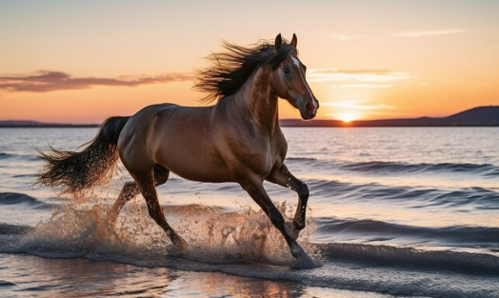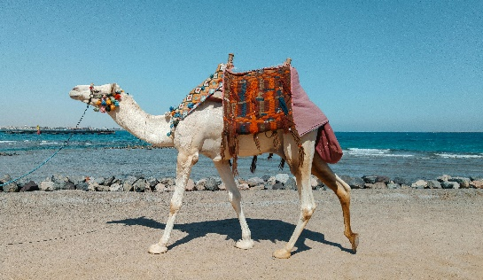

***! Horse riding at Clifton Beach is another thrilling activity for visitors. Beautifully adorned horses are available for guided rides along the shoreline.***

***! Horse riding at Clifton Beach is another thrilling activity for visitors. Beautifully adorned horses are available for guided rides along the shoreline.***

***! Camel riding at Clifton Beach is a fun and iconic activity for visitors. Decorated camels offer safe rides guided by skilled handlers.***

**Activities and Adventures for Everyone**

Clifton Beach is a hub of activity, offering a wide range of recreational opportunities for visitors of all ages. Families can enjoy camel and horse rides along the shore, while children delight in flying kites or building sandcastles. Food vendors selling traditional snacks like roasted corn (bhutta), spicy chaat, and ice-cold drinks add a local flavor to the experience.  
  
For adventure enthusiasts, the beach offers activities like jet skiing, quad biking, and beach buggy rides. The open spaces also make it a popular spot for cricket and football matches, where groups of friends gather for friendly games against the backdrop of the ocean.

**Clifton Beach, – A Coastal Paradise in the Heart of Pakistan**

Clifton Beach, famously known as Sea View, is an iconic and treasured destination in Karachi, Pakistan. Nestled along the Arabian Sea, this remarkable stretch of coastline offers a harmonious blend of natural beauty, cultural vibrancy, and recreational opportunities. A visit to Clifton Beach is more than just a day at the seaside – it is an experience that captures the essence of Karachi’s dynamic spirit.  
  
With its golden sands, rhythmic waves, and refreshing sea breeze, Clifton Beach is a place where people from all walks of life come together to relax, explore, and create unforgettable memories. From family picnics to romantic sunsets and thrilling water sports, this destination offers something special for everyone.  
  
Clifton Beach is not just a modern hotspot; its roots trace back to the colonial

era when it served as a premier destination for the elite. Over time, it has evolved into a vibrant public space that welcomes thousands of visitors daily. Despite Karachi's rapid urban development, Clifton Beach remains a timeless symbol of the city’s coastal charm and a testament to its multicultural identity. The scenic beauty of Clifton Beach is one of its most captivating features. Stretching for miles along the Arabian Sea, the beach offers panoramic views of the ocean that are particularly stunning during sunrise and sunset. The golden sands, coupled with the soothing sound of crashing waves, provide a serene escape from the hustle and bustle of city life.  
  
The cool sea breeze, even during Karachi’s warmer months, makes the beach a perfect retreat for relaxation and rejuvenation. Whether you want to take a quiet stroll along the shore, sit on the sand and listen to the waves, or simply enjoy the picturesque surroundings, Clifton Beach promises an unmatched experience of natural tranquility.

**LOCATION**

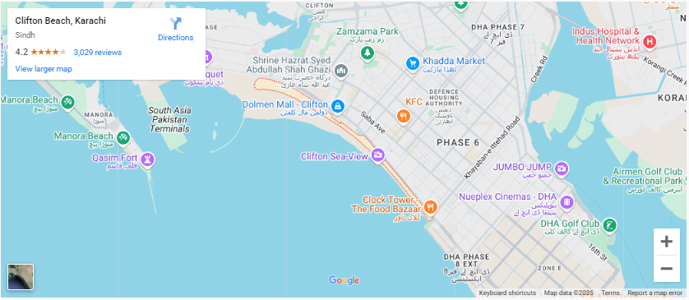

**Clifton Beach is located in the Clifton area of Karachi, along the Arabian Sea coastline, near the Boat Basin.**

**Why Visit Clifton Beach?**

**Whether you’re seeking a tranquil escape from the city, an adventurous day filled with activities, or a glimpse into Karachi’s lively culture, Clifton Beach offers it all. It is a must-visit destination for anyone exploring Karachi, promising unforgettable moments against the backdrop of the Arabian Sea.**



**FEATURED PRODUCT**









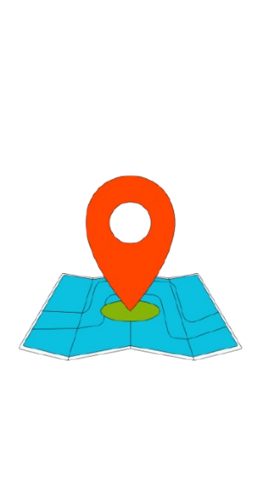

**SHOP LOCATION**

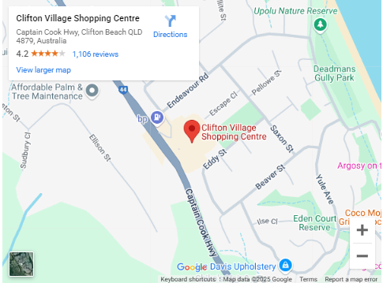

**Clifton Village Shopping Center is located in the Clifton area of Karachi, near the main Clifton Road. It is close to the iconic Clifton Boat Basin.**